Paper 2. Regression
Obstructive environmental struggles in time, Peru 1980-2020

Abstract

Introduction/Theory
The higher number of challengers per daily protest evidence a collective action which involve the coordination of diverse social movement organizations. The scale of contentious events are usually associated to the number of participants but this number is rarely captured in the protest event catalogs built for social research. Instead, the number of challengers participating in a daily base protests is an indicator of the level of coordination involved in the preparation of the performances of struggle and its execution.
In this paper I will state that the coordination of environmental campaigns of struggle in which obstructive performances were executed are increasing since 1980 to 2020 as can be evidenced by the multiple linear regression considering as dependent or outcome variable the number of challengers involved in a daily base protest, the number of performances executed in each protests, and the base categories obstructive performances and environmental claims as values for their respective variables, and the year as an ordinal variable.

Data and Methods
The analysis regarding the measure of the escalation of environmental protests executing obstructive performances since 2001 to 2020, consider for the application of a multivariate linear regression the following variables: number of challengers (act_n_6), número de performances (perf_n), type of performances (perf_id), type of claims (dem_id), and year (y).

Sample and population
The unit of analysis of Protest Event Analysis (PEA) (Koopmans and Rucht 2002) and the construction of contentious event catalogues (Tilly 2002) based on the registration of certain features of those events mainly relative to who protests whom, how and why (Wada 2004).
The Peruvian Protests Database (BPSP are its Spanish acronyms) was developed mainly under the direction of Moises Arce (2014a; 2014b) codifying 21,921 protest events reported in the three main national newspapers (El Comercio, La República and Expreso) since January 1st 1980 and December 31st 2020 based in the revision of each daily edition of those sources in the archives.
The size of the sample selected to run the multivariate linear regression is 11,543 protests events, which corresponds to the total protests events registered in Peru since 2001-2020.

Variables definition and descriptive statistics
Table 1 showed the definition and descriptive statistics for the five variables comprehended in the multivariate regression analysis regarding the coordination of different challengers on the execution of obstructive performances for the revindication of environmental claims over time since 2001 to 2020.
At this point is important to define those variables in a manner in which its measurement could make sense for the analysis and interpretation of political contention using the multivariate linear regression as a quantitative technique for inference.
The variable act_n_6 is measuring the number of challengers (collective actors without access to the political decisions) in a protest, this number was registered by the count of every labeled organization or population mentioned expressly as participants in the daily newspapers reviewed to register the protests events and its attributes of interest. The mean of number of challengers per protest among the 11,543 protests events counted from the year 2001 to 2020 is 1.296, which indicates the participation of one challenger per protest with a standard deviation of 0.66 challengers from the mean.
The variable perf_n is measuring the number of performances executed in the same protest event during one day. In this manner, one-day protest event could imply the demonstration of several performances as a riot, a march, and a road blockade, among others. A higher number of performances executed in a protest is indicative of the upward scale of the contention, due to the higher level of coordination in the execution of multiple performances of struggle in a daily protest. The mean for the variable perf_n is 1.374 which should be interpreted as, among the sample of protests occurred in Peru since 2001 to 2020, as if in average between one and two performances were executed in a daily protests, considering a standard deviation of 0.63.
The variable perfor_id is measuring the type of performances executed, considering its grouping based in the recategorization of its initial values in the original variable perf_1_code, depending on its differentiated potential to obstruct capital circulation in a national economy base (obstructive performances), its potential to disrupt the rate of profit or rate of surplus value of a particular branch of industry or corporation (disruptive performances), its potential to radically demand the satisfaction of protest claims by struggle performances which also involve higher levels of repression (radical performances), and a category of others in which the lowest frequencies were aggregated. The mean and standard deviation of this variable is not meaningful for the analysis of the contentious politics, because its measured as a categorical nominal variable.
The variable dem_id is measuring the type of claim in regard of which the protest was being executed, this implies that eight categories of labor, environmental, territorial, water energy and health access, infrastructure, public managerial decisions, national budget, and other claims. The interpretation of the mean and standard deviation couldn't be considered for analysis because is a nominal categorial variable.
Por último, la variable año y se define como la variable temporal from 2001 to 2020, years in which the expansion of the extractive frontier started with the foreign direct investment not only from US, but from China, Canada and Japan, in which I focus to observe its effect on the dependent variable act_n_6 which is measuring our outcome of interest: the higher level of coordination between different challengers executing a protest, observed by the higher number of challengers counted in the variable act_n_6.
Table 1.
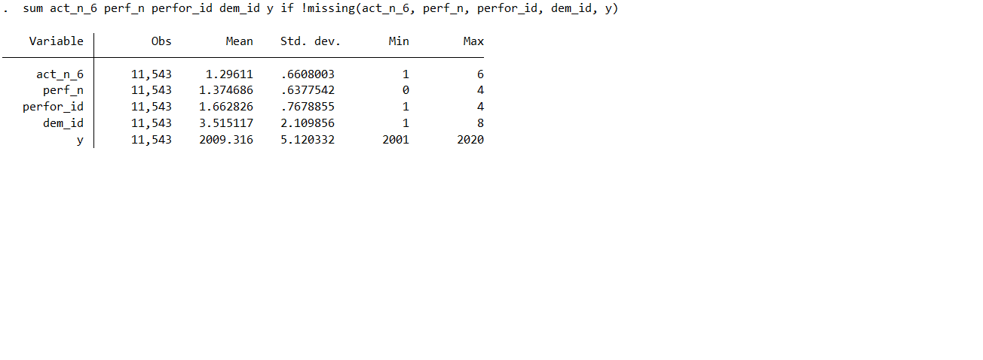

Results
The higher the number of challengers, the higher the level of coordination for collective action. But also, the upward scale of a protest due to the participation of different challengers involve the execution of different performances of struggle in a single daily protest. These assumptions oriented theoretically the following multivariate regression analysis, by exploring its consistency in a concrete field of contention.
The following hypothesis is stated: the number of performances as a variable measuring the count of different performances of struggle is correlated positively with the number of challengers as a measure of the level of coordination for the execution of obstructive environmental protests in the Peruvian contention from 2001-2020.
As the Table 2 evidenced, the multivariate regression of the number of performances and year over the number of challengers at environmental obstructive protests in Peru since 2001-2020, showed an increasing correlation over time. The effect of the variable year over the outcome of interest is showed in the
Table 2. Multivariate regression of number of performances, and year over the number of challengers at environmental obstructive protests, Peru 2001-2020
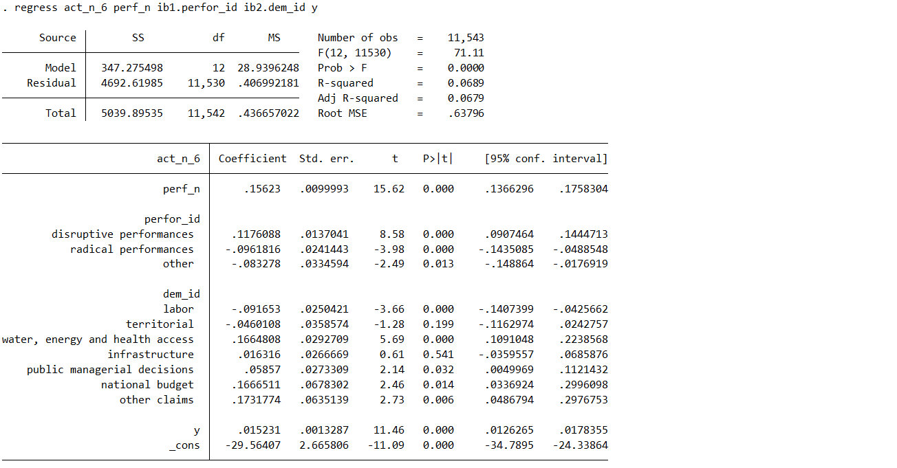

The importance of the 12 cases

The model not explains

